Discussion and Conclusions as of 10/26/2016

SOA recording during saccades between targets in depth

Aka disjunctive saccades, aka saccade-vergence interactions , aka combined saccade-vergence movements

In this study, we conducted a detailed analysis of the activity of near-response cells located in the supra-oculomotor area (SOA) while monkeys made saccades between targets at a range of depths. Because we used physical targets, congruent accommodation and disparity cues were available for the planning and execution of these saccades. As many researchers have previously described, there is no doubt that vergence velocity, defined as the difference between left and right eye velocity, is much greater in magnitude during saccades than is ever observed during non-saccadic vergence movements. Despite this, there is no consensus among researchers about how vergence velocity reaches these speeds. Two incompatible explanations have been proposed. The first is that specialized vergence burst cells generate a specific enhanced vergence velocity command that is added to conjugate motor commands controlled by saccadic burst generators (Bussetini and Mays 2005). This is described as an enhancement of the normally slow vergence signal via an interaction with the conjugate motor command, based on the observation that peak vergence velocity is correlated with conjugate eye velocity. The second hypothesis is that saccadic burst neurons directly generate disconjugate saccades. This requires the saccadic system to operate separate monocular pathways for each eye, which is in conflict with the traditional view of saccadic bursts as conjugate velocity commands. Supporting this hypothesis, a statistical analysis of saccadic burst neurons in the PPRF suggests that the activity of a majority of cells is better correlated with one eye than the other during disconjugate saccades, casting doubt on whether the system is truly conjugate.

200 
Spi kerate 
Vergence Velocity 
100 
10 
Vergence Angle 
1000 
1500 
Time (ms) 
2000 
2500 

Our results suggest that a third hypothesis may better explain this complex behavior. Based on observations from Maxwell and King (1992), we propose that the rapid vergence velocities observed during saccades with vergence are almost entirely due to the same mechanism that produces vergence transients during conjugate saccades. It has already been shown that near-response cells do not respond to conjugate saccades, even though vergence velocity can exceed 200 deg/s. Our results confirm that near-response cells do not respond to transients made during disconjugate saccades either. This is clearly shown in figure 1. This cell pauses its activity whenever the eyes diverge, but have no reaction to the rapid divergence that accompanies many converging saccades. Because vergence transients are symmetrical (meaning the final vergence angle does not change due to the transient vergence movement), it is reasonable to assume that a large part of the convergence is also due to the transient -- not the vergence system. In figure 2, we plot the maximum vergence velocity for converging saccades as a function of vergence amplitude. Because vergence transients occur even during conjugate saccades (vergence amplitude = 0), the variance is very large. Our hypothesis suggests that the maximum vergence velocity is actually a function of the vergence transient added to an underlying vergence movement driven by near-response cells. Under this hypothesis, the SOA-driven vergence velocity is represented by the minimum value, shown as a red line, and increases exponentially with vergence amplitude (in degrees).

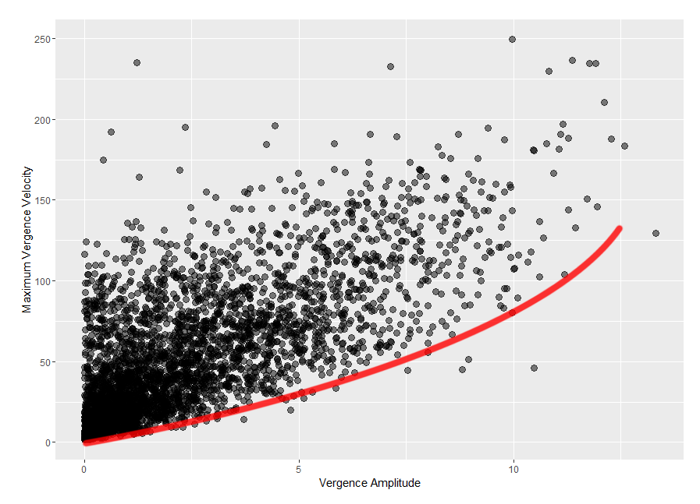

Others have observed that vergence velocity traces during these movements is not a linear sum of the velocity traces observed during an equivalent conjugate saccade and slow vergence movement of the same amplitude. Indeed, our results agree that even after removing the effect of the transient, vergence velocity is still increased. In the figure discussed above, a 10-degree convergence may add 75 deg/s, compared with X deg/s typically seen in saccade-free vergence. This is well below the peak velocities of 200 deg/s or more that we observe if transients are not accounted for. There are several factors that are likely to contribute to this slight enhancement of vergence velocity. First, we must consider the physical requirements for moving the eye -- the oculomotor plant. The viscous component of the plant resists changes in eye velocity meaning that more neural drive is needed to move the eyes from static positions than when the eyes are moving rapidly, as is the case during saccades. This means that without any change in the signal from the vergence system, the eyes will converge more rapidly during saccades.

Divergent 
15 
10 
-200 
-400 
200 400 
-200 
-400 
Convergent 
400 
200 
Time from Saccade Onset (ms) 

Second, in addition to our convergence-sensitive cells, we also describe far-response cells that pause their activity only during converging saccades. These could form a push-pull mechanism such that these pauses reduce the divergence drive resulting in increased convergence without requiring additional activity from near-response cells. The fact that these pauses are restricted to diverging saccades and not non-saccadic vergence (VERIFY THIS) suggests that there may be an interaction between the saccadic and vergence system as Busettini and Mays (2005) suggest, though our analysis does not support their assumption that this interaction is responsible for a burst of spikes during convergence, which we do not observe.

Divergent 
Convergent 
15 
10 
-400 
-200 
o 
200 400 
-400 -200 0 
200 
400 
Time from Saccade Onset (ms) 

Additional Points:

* Duration of "burst" is longer than the duration of the vergence enhancement/transient convergence velocity
* Transients are idiosyncratic – each monkey has a different pattern of transients
  + Transients are somewhat predictable given information about the upcoming saccade
  + Transients can be multi-phasic – very difficult to predict
  + Affect by alertness of monkey?
* Sensitivity to vergence velocity is significantly reduced during "enhancement" compared with non-saccadic vergence in all cells with a significant difference.
  + Stated another way, cells don't respond to the spike in vergence which we claim is due to the transient
* There is no clear divide between "velocity cells" and "Not-velocity-cells"
  + Our cells demonstrate a range of velocity sensitivities:
  + conv_is_slow 
    TRUE 
    verg_angle < 0 
    TRUE 
    Convergence 